**2: Implementing Dependency Injection:  
//pom.xml**

<project xmlns="http://maven.apache.org/POM/4.0.0" xmlns:xsi="http://www.w3.org/2001/XMLSchema-instance" xsi:schemaLocation="http://maven.apache.org/POM/4.0.0 https://maven.apache.org/xsd/maven-4.0.0.xsd">

<modelVersion>4.0.0</modelVersion>

<groupId>com.springcore</groupId>

<artifactId>Springcore</artifactId>

<version>0.0.1-SNAPSHOT</version>

<name>SpringCore and Maven</name>

<dependencies>

<dependency>

<groupId>org.springframework</groupId>

<artifactId>spring-context</artifactId>

<version>5.3.20</version>

</dependency>

</dependencies>

</project>

**//BookRepository.java**

package com.book.repo;

public class BookRepository {

public void saveBook(String bookName) {

System.***out***.println("Book '" + bookName + "' saved to the database.");

}

}

**//BookService.java**

package com.book.service;

import com.book.repo.BookRepository;

public class BookService {

private BookRepository bookRepository;

public void setBookRepository(BookRepository bookRepository) {

this.bookRepository = bookRepository;

}

public void addBook(String bookName) {

System.***out***.println("Processing the book: " + bookName);

bookRepository.saveBook(bookName);

}

}

**//App.java**

package com.book;

import com.book.service.BookService;

import org.springframework.context.ApplicationContext;

import org.springframework.context.support.ClassPathXmlApplicationContext;

public class App {

public static void main(String[] args) {

ApplicationContext context = new ClassPathXmlApplicationContext("applicationContext.xml");

BookService bookService = context.getBean("bookService", BookService.class);

bookService.addBook("Wings Of fire");

}

}

**//ApplicationContect.xml**

<?xml version="1.0" encoding="UTF-8"?>

<beans xmlns="http://www.springframework.org/schema/beans"

xmlns:xsi="http://www.w3.org/2001/XMLSchema-instance"

xsi:schemaLocation="http://www.springframework.org/schema/beans

https://www.springframework.org/schema/beans/spring-beans.xsd">

<bean id="bookRepository" class="com.book.repo.BookRepository"/>

<bean id="bookService" class="com.book.service.BookService">

<property name="bookRepository" ref="bookRepository"/>

</bean>

</beans>

**//Structure:**

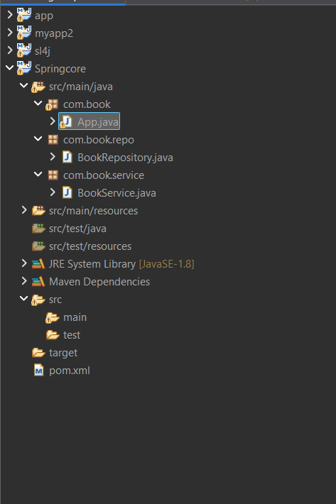

**//Output:**